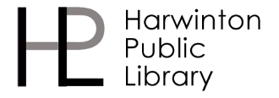
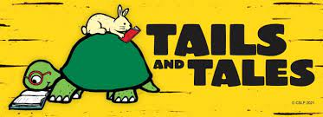
Summer Reading 2021

Registration

Parent’s email/phone number (so we can contact you if you are a raffle winner!)

Summer Readers:

Name _____________________________________ Age ____ School ____________________

Name _____________________________________ Age ____ School ____________________

Name _____________________________________ Age ____ School ____________________

Name _____________________________________ Age ____ School ____________________

Name _____________________________________ Age ____ School ____________________

Return this registration form through our Book Drop or take a picture of it and email it to Miss Amanda at childrens@harwintonlibrary.org

You’ll be entered in our weekly raffle drawings to win a gift card to a local business. Raffle winters will be randomly selected each Friday morning during Summer Reading. Good luck!

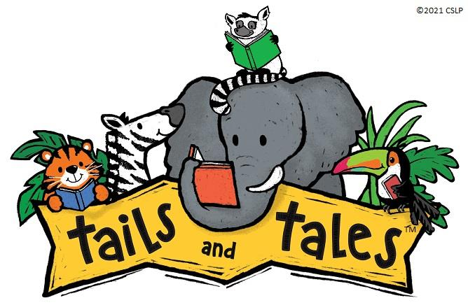
Harwinton Public Library 2021 Grand Prize Entry Form

Name_____________________ Age_____ School____________________
Parent’s email/phone number (so we can contact you if you win!) ____________________
Using this sheet, tell us what your favorite book was this summer, by using a list of descriptive words, drawing a picture, or writing about why you liked it so much! Use your imagination!

*Return this form by July 28th via our book drop, or take a photo and email it to us at childrens@harwintonlibrary.org
Harwinton Public Library 2021
First Selectman for a Day Raffle/T-Shirt Order form
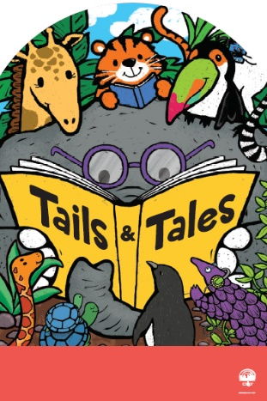
Name_____________________ Age_____ School____________________
Parent’s email/phone number (so we can contact you if you win!) ____________________

Book Title
1.___________________________________

2.___________________________________

3.___________________________________

4.___________________________________

I have read 4 books, and my t-shirt size is (circle one) Small Medium Large

*Return this form by July 28th via our book drop, or take a photo and email it to us at childrens@harwintonlibrary.org.

